EXPT NO:6 | IMPLEMENTATION OF MULTIVARIATE DISPLAYS
DATE: 24.01.2026 | IMPLEMENTATION OF MULTIVARIATE DISPLAYS

PRE-LAB QUESTIONS
- Why are multivariate displays important in AI analytics?

Multivariate displays are important in AI analytics because they allow simultaneous visualization of multiple variables. They help in understanding complex relationships, interactions, and dependencies between features, which is essential for analyzing high-dimensional data used in AI models.

- How do parallel coordinates differ from scatter plots?

Scatter plots visualize relationships between only two variables at a time using x and y axes. Parallel coordinate plots, on the other hand, represent multiple variables simultaneously by mapping each variable to a parallel axis, allowing analysis of high-dimensional data in a single view.

- What challenges exist in interpreting multivariate plots?

Challenges include visual clutter, overlapping data points, difficulty in identifying clear patterns, and increased cognitive load. Poor scaling and lack of interaction can also make multivariate plots hard to interpret.

- Where are trellis displays commonly used?

Trellis displays are commonly used in exploratory data analysis, performance comparison, time-series analysis, and AI model evaluation. They are especially useful for comparing patterns across categories such as departments, classes, or model variants.

- How does multivariate visualization aid model evaluation?

Multivariate visualization helps evaluate AI models by enabling comparison of multiple performance metrics simultaneously, such as accuracy, precision, recall, and loss. It assists in identifying trade-offs, detecting overfitting, and understanding feature influence on model outcomes.

IN-LAB EXERCISE:
OBJECTIVE : To implement advanced multivariate displays for complex data analysis.
SCENARIO: A retail analytics firm studies sales, profit, customer segment, and region to optimize business strategy.
IN-LAB TASKS (Using R Language) • Create parallel coordinate plots • Generate bubble charts • Implement trellis displays by region

Code:

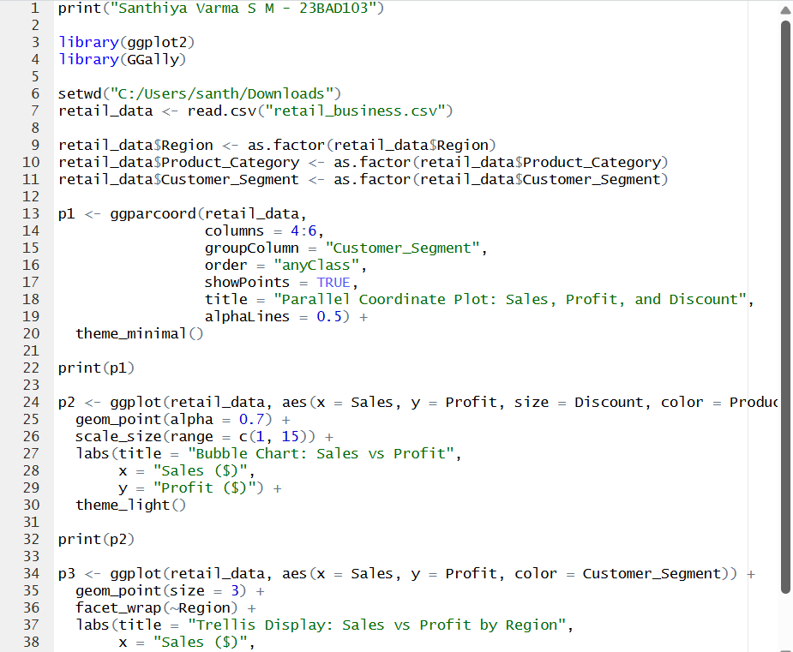
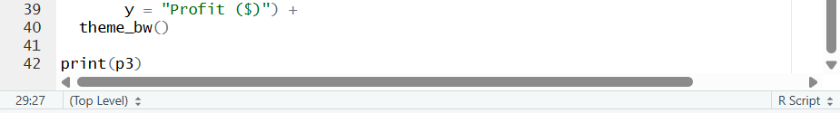

Output:

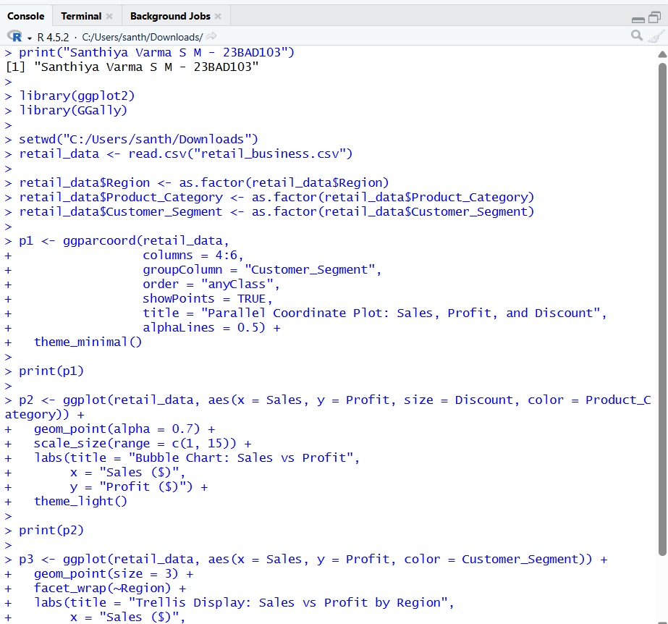

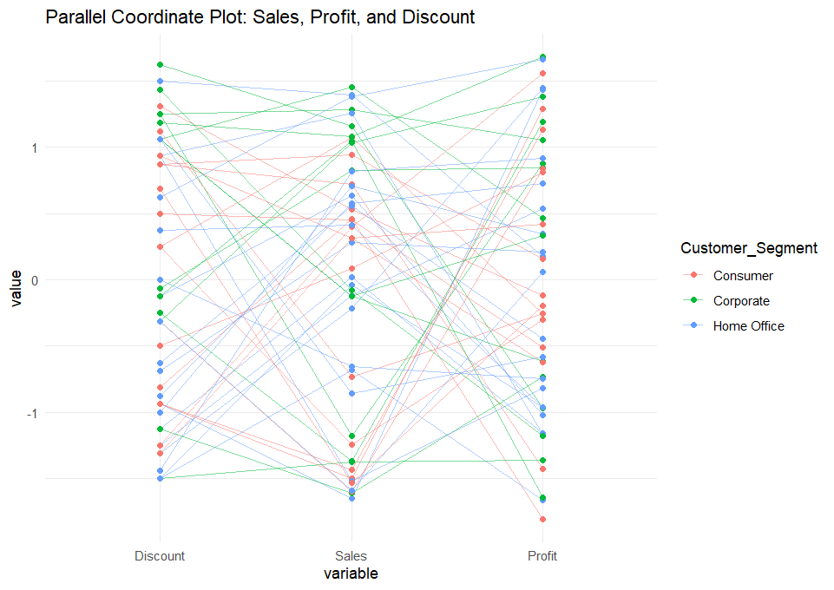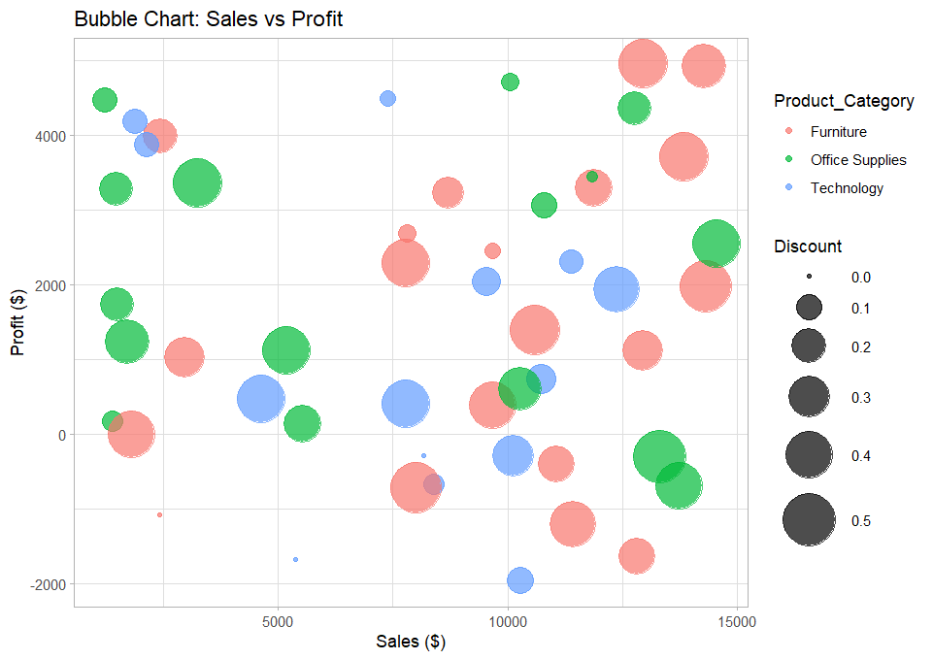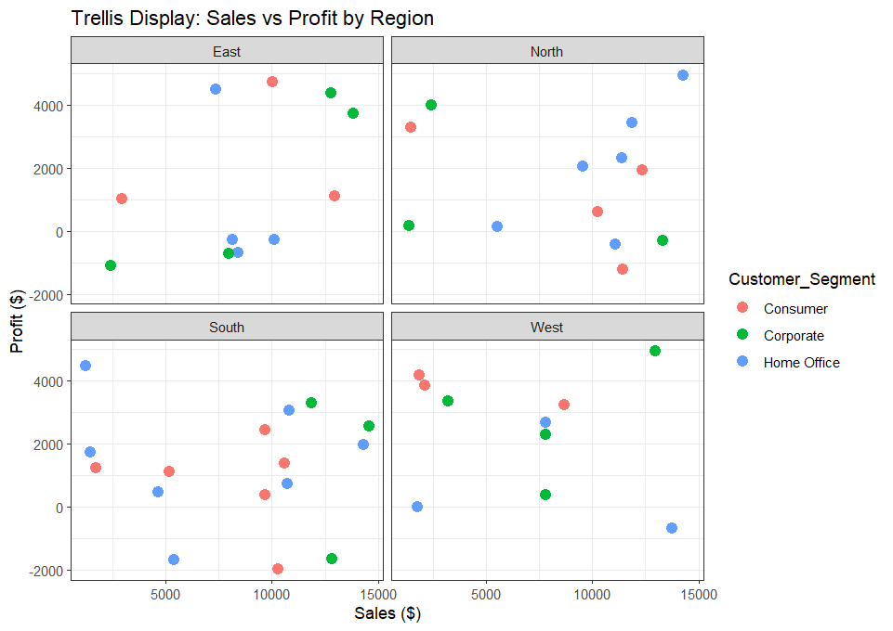

POST-LAB QUESTIONS
- What insights are gained from parallel coordinates?

Parallel coordinate plots visualize multiple variables such as sales, profit, and discount simultaneously. They help identify relationships and patterns across different customer segments. Outliers and abnormal trends can be easily detected. This aids in understanding how variables influence each other.

- How does faceting simplify complex data?

Faceting divides large datasets into smaller subplots based on categories like region. It reduces visual clutter and makes comparisons easier. Trends can be analyzed separately for each group. This improves overall data clarity and interpretation.

- What limitations exist in bubble charts?

- Bubble charts become cluttered when many data points overlap.
- Comparing bubble sizes accurately is difficult.
- Small size variations may be misleading.
- Not suitable for very large datasets.

- How can these displays support AI-driven recommendations?

These visualizations help analyze customer behavior and business trends. They support feature selection and segmentation. Model outputs become easier to interpret visually. This improves the accuracy of AI-driven recommendations.

- Suggest improvements for large multivariate datasets.

- Help visualize customer behavior and sales patterns.
- Assist in identifying important features and segments.
- Improve interpretation of AI model outputs.
- Support accurate and explainable recommendations.

LEARNING OUTCOME: Students apply multivariate visualization for business intelligence.

ASSESSMENT
Description | Max Marks | Marks Awarded
Pre Lab Exercise | 5
In Lab Exercise | 10
Post Lab Exercise | 5
Viva | 10
Total | 30
Faculty Signature

